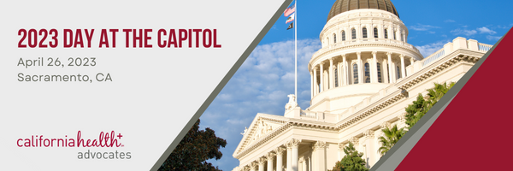

2023 Day at the Capitol
Advocacy & Social Media Toolkit

Legislative Meeting Best Practices
Social Media Advocacy
Capitol Power Hour
Email Templates for Legislative Meetings
State Legislative Process
State Budget Process
If you have any questions and/or need additional support,
please contact Taylor Beckwith at taylor@healthplusadvocates.org

Legislative Meetings

A legislative meeting (or lobby meeting) is a meeting to let your representative, or their staff know what you think about a certain policy or budget priority and try to get them to take action such as supporting or opposing a bill. This is achieved by educating them on why this issue is important to you and your health centers and sharing your personal stories. A legislative meeting is also a great opportunity to get to know your legislators and their staff and build relationships that can support community health center priorities.
Prep Work:
- Schedule your legislative meeting.
  - Submit a meeting request via email.
  - Please feel free to refer to the email template on pg. 5.
- Research your Legislators & District Staff
  - Background
  - Committees they sit on
  - Priorities
  - Projects
- Find Your California Representative HERE
- California Legislative Bill Tracker HERE
- Optional: Prep Meeting with other lobby team members to run through materials, decide roles, figure out logistics, etc.

Sharing Your Story:
- Legislators and staff can read fact sheets and hear from lobbyists. While important, personal stories and experiences are what will help move them to change – how bills impact real people, like you, health center staff patients, and the community.
- Talk about the issue or bill:
  - Why is this important to you/your staff/your patients/your health center?
  - How will this impact you/your staff/your patients/your health center?
  - Why is it important that this bill or budget item passes?
  - Why is this an issue or problem? How will this bill or budget item help solve it?
Best Practices:
- Keep it short and focused.
- Stick to your talking points.
- Make it personal.
- Provide Personal and local examples on the impact of the issue or legislation.
- Make the Ask!

After the Meeting:
- Send a follow-up email: It is important that someone in your group follows up via email, thanking the legislator or their staff for meeting with your group.
  - Please refer to the Email Template Section for more information.
- If you took a photo during the meeting, please post it on your social media accounts!
  - Tag Senator or Assemblymember and @HealthPlusAdv
  - Include an ask or invite them to tour your health center.
  - See Social Media Advocacy on the next page for more information.

Social Media Advocacy

Posting a picture of a legislative visit and tagging a legislator after the visit is a fantastic way to increase awareness around the importance of community health centers and can draw attention to legislators and their impact on this issue. We highly encourage you to use a photo taken from your meeting with a legislator, but if you were unable to get a photo, we encourage you to use a photo that you have taken with your colleagues, team, or CPCA staff!

Take a Photo:
- At the end of your legislative meeting, ask the Legislator or Staff if you could take a virtual group photo.
- Ask for permission to post on your social media account, and ask if they can repost, or also post the photo.

Posting Photo:
- What to say in your post? (See Sample Captions Below)
  - Thank the legislator and/or staff for meeting with you.
  - Add why the legislation is important to your health center, staff, and patients.
- Tag Accounts
  - Tag the Senator/Assemblymember’s social media account.
  - Tag CaliforniaHealth+ Advocates @HealthPlusAdv
- Include Hashtags
  - #DAC2023
  - #ValueCHCs
  - #CHCAdvocacy

Sample Captions for Legislative Visit Photos:

Platform | Topic | Caption
Instagram/Facebook/Twitter | General DAC | Thank you {tag your legislator} for meeting with us today for 2023 Day at the Capitol! We were excited to share our community health center priorities and stories about the amazing work our health centers are doing in your district communities. #DAC2023 #ValueCHCs @HealthPlusAdv
Instagram/Facebook | AB 1549  Prospective Payment System (PPS) Modernization | Thank you {tag your legislator} for meeting with us during our 2023 Day at the Capitol to discuss the importance of community health centers and our priorities. We encourage you to support AB 1549 that will modernize California’s community health centers payment structure to align with care transformation efforts. #DAC2023 #ValueCHCs #CHCAdvocacy @HealthPlusAdv
Twitter | AB 1549  Prospective Payment System (PPS) Modernization | Thank you {tag your legislator} for meeting with us to discuss community health center priorities. We encourage you to support AB 1549 that will modernize California’s community health centers payment structure to align with care transformation efforts. #DAC2023 #ValueCHCs #CHCAdvocacy @HealthPlusAdv
Instagram/Facebook | SB 525  $25 Minimum Wage Bill | Thank you {tag your legislator} for meeting with us and letting us share about the work community health centers are doing! We urge you to oppose SB 525 unless amended, as we support higher wages for community health center workers but need adequate tools for successful implementation. #DAC2023 #CHCAdvocacy #ValueCHCs @HealthPlusAdv
Twitter | SB 525  $25 Minimum Wage Bill | Thank you {tag your legislator} for meeting with us and letting us share about the work community health centers are doing! CHCs need more funding to support workforce and cover the rising costs of employee wages. We hope you oppose SB 525 unless amended! #DAC2023 @HealthPlusAdv
Instagram/Facebook | SB 779  Data Transparency Bill | Thank you {tag your legislator} for meeting with us and letting us share about the amazing work community health centers are doing! We want to encourage you to oppose SB 779, unless amended, as this will add unnecessary reporting requirements for community health centers that already provide robust data and take away from patient care. #DAC2023 #CHCAdvocacy #ValueCHCs @HealthPlusAdv
Twitter | SB 779  Data Transparency Bill | Thank you {tag your legislator} for meeting with us to hear about the work community health centers are doing! We urge you to oppose SB 779, unless amended, as it adds unnecessary reporting requirements and take away from patient care. @HealthPlusAdv #DAC2023 #CHCAdvocacy #ValueCHCs
Instagram/Facebook | Budget Ask: Health Navigation | Thank you {tag your legislator} for meeting with us today! We appreciate your support of our $60 million one-time budget ask that will expand funding for health navigation in community health centers and ensure patients receive culturally and linguistically appropriate health navigation services. @HealthPlusAdv #DAC2023 #ValueCHCs #CHCAdvocacy
Twitter | Budget Ask: Health Navigation | Thank you {tag your legislator} for meeting with us today! We appreciate your support of our $60 million one-time budget ask that will expand funding for health navigation services in community health centers. @HealthPlusAdv #DAC2023 #ValueCHCs #CHCAdvocacy

Capitol Power Hour

Capitol Power Hour is a one-hour period between 12:00-1:00pm (PST) where advocates will organize to create a high amount of digital noise through tweets and posts centered on advocating for community health centers. We intend to create a spike in activity to get the attention of legislators and policy makers and encourage you to post your photos during this time! Post photos from your legislative visits, photos from additional photo opportunities below, or the premade graphics related to our priorities.

Premade graphics for AB 1549, SB 525, SB 779, and the Budget Ask can be downloaded HERE.

Photo Opportunities at DAC
The work that we do is extremely important and should be shared with others! Please participate and highlight your work by taking and sharing photographs throughout the day. Authentic photos are always the best! Below are ideas for different photo opportunities while you are at DAC 2023.

Hashtags: #DAC2023 #ValueCHCs #CHCAdvocacy

Tag: @HealthPlusAdv on Instagram & Twitter
- State Capitol: Take a photo or selfie in front of the California State Capitol.
- Swing Space: Take a photo or selfie in the new Swing Space.
- Legislative Office: Take a photo or selfie in front of your legislator’s office.
- Legislative Visit: If your legislator or staffer agrees, take a photo or selfie at the end of your meeting.
- Colleagues/Team: Take a photo or selfie with your colleagues and lobby team.
- RAC/Consortia: Take a photo or selfie with your consortia members.
- CPCA Staff: Take a photo or selfie with a CPCA staff member.
- CPCA CEO: Find and take a photo or selfie with CPCA’s CEO Francisco Silva.
- Educational Session: Take a photo or selfie of you attending the educational session.
- Lunch Program: Take a photo or selfie during the Lunch Program.
- Legislative Reception: Take a photo or selfie while at The Mix for the Legislative Reception.

Email Templates for Legislative Meetings

Scheduling a Legislative Meeting

Subject: Meeting Request

Dear _______,

On behalf of the Community Health Centers in your district, we would like to request a virtual meeting with Senator/Assemblymember _______ sometime between the dates of _______. Attending the meeting will be _______ (name of the attendees, their titles, and the health centers they represent.

We hope to discuss our 2023 priorities with you. Thank you, I hope to hear from you soon.

Sincerely,

Following up after a Legislative Meeting

Subject: Thank You for meeting with _________________ (Clinic Name/Consortia Name)

Dear _______,

Thank you for meeting with us on ______ (date of MTG) for Day at the Capitol to discuss our policy priorities and budget ask. We enjoyed talking with you about our policy and budget priorities, as well as the issues critical for the staff and patients that community health centers serve.

If legislator is supportive: We are excited to hear that Senator/Assemblymember _____ is supporting _____ (name of policies).

If legislator is supportive of our opposition positions: We are pleased to hear that Senator/Assemblymember _______ opposes ______ (bill number or name or policies).

If legislator/staff asked for additional information: Below (or attached) is information regarding _____that you requested.

Optional: Thank you Senator/Assemblymember _______ for being a community health center advocate.

If any (other) questions arise, please feel free to contact _____ (email). Thank you.

Sincerely,

State Legislative Process

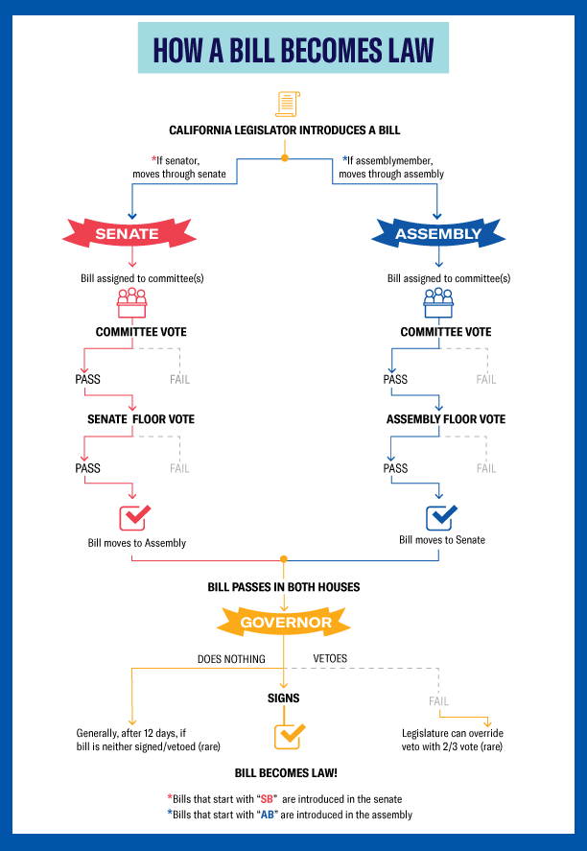

Source: California Capitol Museum https://capitolmuseum.ca.gov/learn/about-the-government/life-cycle-of-a-bill/

State Budget Process

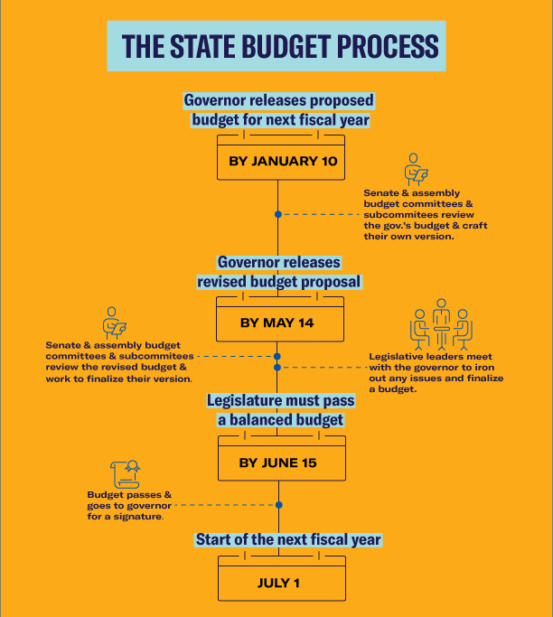

Source: ACLU SoCal – https://www.aclusocal.org/en/ca-legislature-guide

